PETITION TO LIST SUNFLOWER SEA STAR
AS THREATENED OR ENDANGERED
UNDER THE U.S. ENDANGERED SPECIES ACT
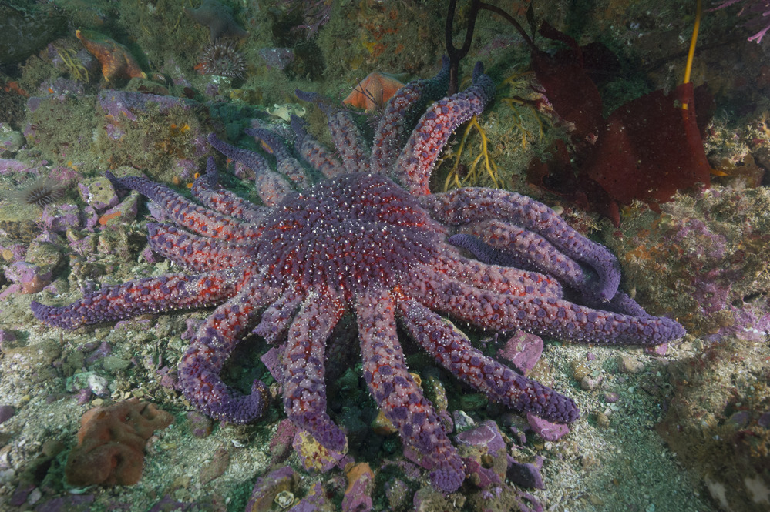
Credit: National Park Service

Before the Secretary of Commerce

August 18, 2021

Notice of Petition
Gina Raimondo, Secretary of Commerce
U.S. Department of Commerce
1401 Constitution Ave. NW
Washington, D.C. 20230
Email: TheSec@doc.gov
Janet Coit, Assistant Administrator for Fisheries
National Marine Fisheries Service
1315 East-West Highway
Silver Spring, MD 20910
Email: janet.coit@noaa.gov
Petitioner:
Miyoko Sakashita
Center for Biological Diversity
1212 Broadway #800
Oakland, CA 94612
Email: miyoko@biologicaldiversity.org
The Center for Biological Diversity (Center, Petitioner) submits to the Secretary of Commerce and the National Oceanographic and Atmospheric Administration (NOAA) through the National Marine Fisheries Service a petition to list the sunflower sea star, Pycnopodia helianthoides, as threatened or endangered under the U.S. Endangered Species Act (ESA), 16 U.S.C. § 1531 et seq.
The Center is a non-profit, public interest environmental organization dedicated to the protection of native species and their habitats. The Center has more than 1.7 million members and online activists worldwide. The Center and its members seek to conserve imperiled species like the sunflower sea star through science, policy, and effective implementation of the ESA.
The Service has jurisdiction over this Petition. This petition sets in motion a specific process requiring the Service to make an initial finding as to whether the Petition “presents substantial scientific or commercial information indicating that the petitioned action may be warranted.” (16 U.S.C. § 1533(b)(3)(A).) The Service must make this initial finding “[t]o the maximum extent practicable, within 90 days after receiving the petition.” (Id.) Petitioner need not demonstrate that the listing is warranted, but rather present information demonstrating that such action may be warranted. The Center believes the best available scientific information demonstrates that listing the sunflower sea star as threatened or endangered is warranted, and the available information clearly indicates that listing the species may be warranted. As such, the Service must promptly make a positive finding on the Petition and commence a status review as required by 16 U.S.C. § 1533(b)(3)(B).
Respectfully submitted this August 18, 2021.

Table of Contents

Introduction 1
1. Natural history of the sunflower sea star 2
a. Description 2
b. Taxonomy 2
c. Habitat and range 3
d. Life history 3
e. Diet and feeding ecology 5
f. Abundance and status 5
g. Conservation status 7
2. The sunflower sea star should be listed as threatened or endangered
under the U.S. Endangered Species Act 8
a. The present or threatened destruction, modification, or
curtailment of its habitat or range 8
b. Overutilization for commercial, recreational, scientific,
or educational purposes 10
c. Disease or predation 11
d. Other natural or manmade factors affecting sunflower
sea star’s continued existence 14
e. The inadequacy of existing regulatory mechanisms 19
3. Critical habitat and protective regulations 23
Conclusion 23

Introduction
The sunflower sea star (Pycnopodia helianthoides) is critically endangered. Since 2013 a severe disease outbreak has decimated more than 90 percent of the sunflower sea star population. From California to Alaska surveys showed 80 to 100 percent population declines between 2013 and 2017. The sea star has declined to near-zero densities along the outer coasts of the contiguous United States and Mexico. Between 2018–2019, only 20 of 3976 total surveys in all of the United States and Mexican contiguous outer coast recorded animals. No animals were recorded in California in 2019, and none have been recorded in Baja California since 2015. Sea star wasting disease is a gruesome killer that causes lesions; melting, twisting limbs; arm loss; and death. The disease outbreak has been called a “zombie apocalypse” of the sea.
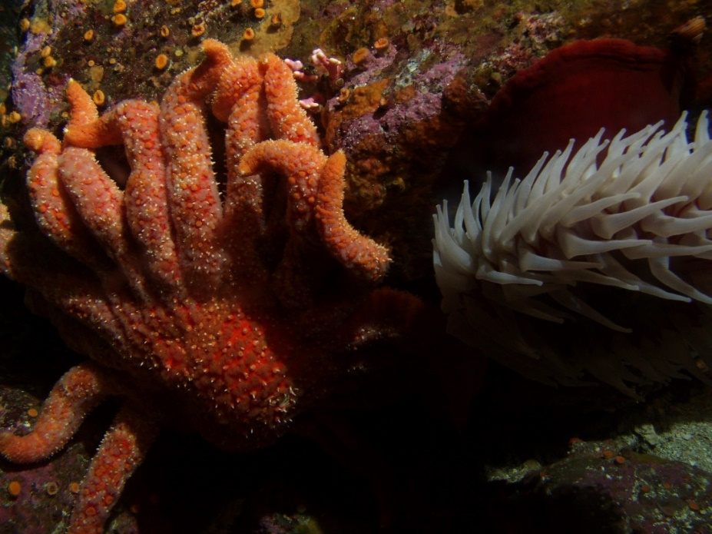
A sunflower sea star. Credit: Michael Carver/CBNMS
The sea star wasting disease outbreak was particularly deadly for sunflower sea stars, whose populations have not recovered. The disease affected sea stars throughout their range from Alaska to southern California. Sea star wasting disease is tied to climate change. Warm waters resulted in more severe and deadly effects on sunflower sea stars. While disease is the primary driver of extinction risk for sunflower sea stars, they are so imperiled that they are also extremely vulnerable to other threats such as ocean acidification, pollution, and harvest.
Sunflower sea stars are one of the world’s largest sea stars with 16 to 24 arms that can extend more than three feet across. They are also a speedy sea star and can travel more than five feet per minute. Sunflower sea stars come in an array of colors—purple, red, orange, yellow, green, and brown.
The mass die-off of sunflower sea stars not only leaves them in danger of extinction, but it is also devastating for the entire kelp forest ecosystem in which they live. Sunflower sea stars are a keystone species and a top predator in the intertidal zone. In the absence of a healthy population of sea stars, sea urchins can proliferate and devour the kelp forests that provide habitat for a many fish and other wildlife. The decline of sunflower sea stars has caused a cascade of harmful changes in the ocean food web.

Natural history of the sunflower sea star

Description
Sunflower sea stars are one of the world’s largest sea stars. They typically have 16 to 24 arms that can span up to one meter, or 3.3 feet, across. Sunflower sea stars vary in color—including orange, red, brown, yellow, green, and purple.
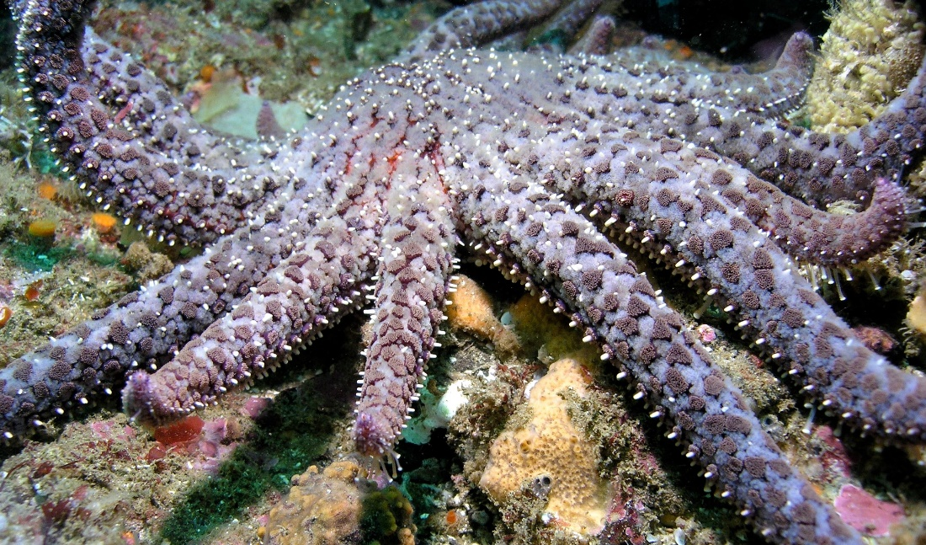
Credit: Kevin Lafferty, USGS.

Taxonomy
Kingdom, Animalia
Subkingdom, Bilateria
Infrakingdom, Deuterostomia
Phylum, Echinodermata
Subphylum, Asterozoa
Class, Asteroidea
Superorder, Forcipulatacea
Order, Forcipulatida
Family, Pycnopodiidae
Genus, Pycnopodia
Species, Pycnopodia helianthoides (Brandt, 1835) – Sunflower Star

Habitat and range
Sunflower sea stars are distributed throughout intertidal and subtidal coastal areas of the Northeastern Pacific Ocean. Sunflower sea stars are found in kelp forests, near shore sand, and rocky bottoms. They range from Alaska to southern California, and they may also be found off the coast of Baja, California.
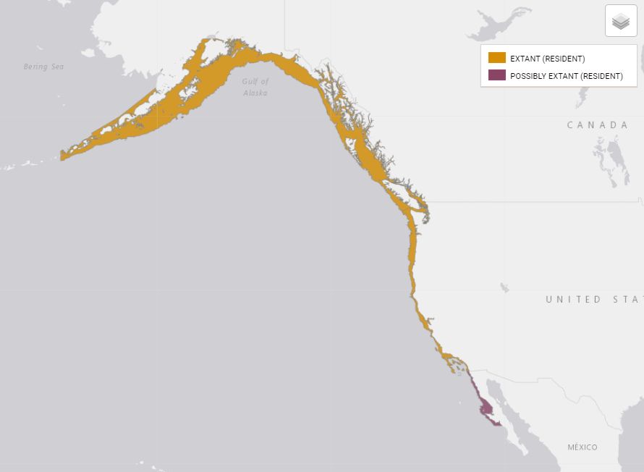
Figure 1. Map of sunflower sea star range. Source: Gravem 2021 https://www.iucnredlist.org/species/178290276/197818455

Life history
Sunflower sea stars are broadcast spawners, requiring proximity for successful reproduction. After spawning, they have a larval stage in which they swim and are carried by currents. At about 50 to 146 days they metamorphose into a baby sea star. Sunflower sea stars settle and undergo a transformation typical for echinoderms.
As juveniles, sunflower sea stars have five arms. They tend to grow rapidly in the first year. Overall, they grow at a rate of approximately 2 to 8 cm per year. Their growth is dependent on the availability of food, with larger sea stars consuming more prey.
Sunflower sea stars grow more arms as they mature and typically have 16 to 24 arms as adults. They develop symmetrically. They grow to about 1 meter diameter and up to 5 kilograms in weight. Their growth depends on meals and environmental factors.
It is estimated that sunflower sea stars. They are long-lived, with a lifespan of up to 65 years.
They are one of the fastest sea stars, and they can travel at speeds up 160 cm (5.2 feet) per minute. They use their 15,000 tube feet to speed along and voraciously hunt for prey.
Sea stars are predators, and sunflower sea stars are a top predator of Pacific coast intertidal invertebrates. They also forage on dead squid, seabirds, and fish. Sunflower sea stars use chemical cues to locate and forage on their prey.
Sunflower sea stars are considered essential for maintain the intertidal ecosystem. They are considered a keystone species with control over equilibrium of ecosystem. Sunflower sea stars control purple urchins in nearshore habitats. This helps maintain kelp forests and the entire diversity of wildlife that depend on kelp forests. Without sunflower sea stars, the entire ecosystem can undergo a shift, a tropic cascade, toward what is called an urchin barren.
The absence of sunflower sea stars has dramatic effects on the intertidal ecosystem, resulting in less ecosystem health and richness. For example, observations noted that the sea star wasting disease outbreak in sunflower sea stars resulted in a 311 percent increase in urchins between 2013 to 2016. The absence of the sunflower sea stars resulted in higher urchin grazing of kelp forests, and it depleted the kelp. Kelp stipes declined 30 percent in two years after the disease outbreak.

Diet and feeding ecology
Sunflower sea stars are predatory asteroids and are generalist feeders. They prey on a wide range of bivalves, gastropods, crustaceans, and other animals. Their preferred prey is purple urchin, butter clams and scallops; and they also forage on other bivalves and carrion of herring, squid and dogfish. Sunflower sea stars can eat a purple urchin whole, and then they expel the hard shell. In Alaska, they commonly prey upon oysters and clams. In the Pacific Northwest, they are known to prey upon gastropods, bivalves, and crustaceans.
The meals of sunflower sea stars affect their size and life history. Larger animals are found on soft surfaces than those that inhabit hard substrates, and the juveniles are often found on kelp habitat where they forage on detritus and microflora and fauna.

Abundance and status
Historically, sunflower sea stars were common throughout their range. They were especially abundant in waters shallower than 25 meters. For example, in the Salish Sea prior to 2015, surveys would detect approximately 9.9 animals per survey. However due to sea star wasting disease, abundance plummeted to fewer than two animals per survey. Historically, surveys from California to Alaska typically reported between 2 and 100 sea stars. Surveys since 2014 more commonly reported none or only 1 sunflower sea star.
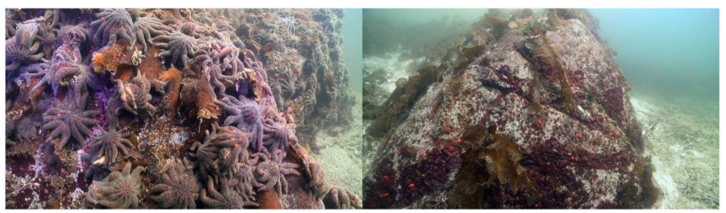
Figure 2. Comparative presence of Pycnopodia helianthoides in October 2013 at Croker Island, Indian Arm, a coastal fjord near Vancouver, British Columbia, Canada. The pictures were taken three weeks apart, prior to (left) and after (right) the onset of Sea Star Wasting Syndrome. Photo credit: Neil McDaniel, www.NeilMcDaniel.com Source: Montecino-Latorre
Beginning in 2013, sea star wasting disease decimated the global population. Sunflower sea stars were highly susceptible to sea star wasting disease, and studies revealed a decline of 80 to 100 percent across their entire range. Sea star wasting disease also extirpated local populations within 21 days. For example, sunflower sea stars have been functionally extirpated in the Northern Channel Islands. Across their range, sunflower sea stars have shown little to no recovery. A review of all population surveys estimated a decline of 90.6 percent since the 2013 sea star wasting disease outbreak, with an estimated 6,350,835,461 individuals pre-decline and 80,627,721 mature individuals in 2019.
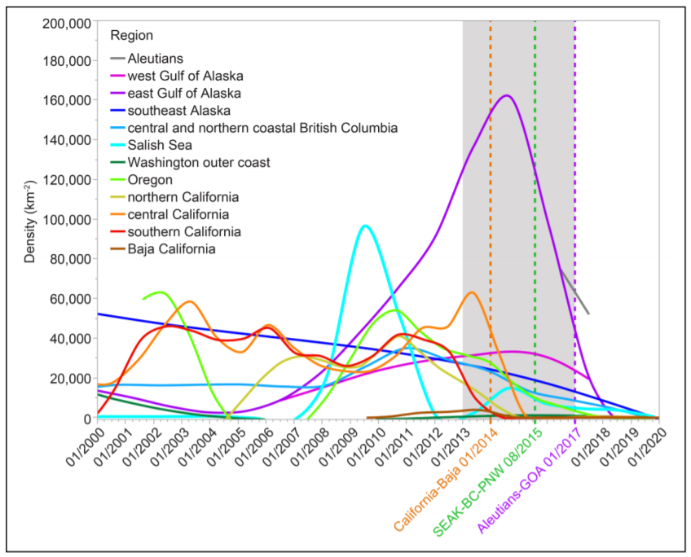
Figure 3. Smoothed fits of the average densities of Pycnopodia helianthoides over time (2000-2019) and among regions. The gray box indicates the years in which the sea star wasting syndrome outbreak occurred (2013-2017). Dotted lines indicate the dates used in each region to designate populations as pre or post SSWS-induced declines. Jan 1, 2014: California (northern, central, southern) and Baja California. Aug 1, 2015: southeast Alaska, coastal, northern and central British Columbia, Salish Sea, Washington outer coast, and Oregon. Jan 1, 2017: Aleutians, west and east Gulf of Alaska. Source: Gravem 2021.

Conservation status
The sunflower sea star is classified as “critically endangered” by the International Union for Conservation of Nature (IUCN). The critically endangered classification was based on population decline because “the global population has declined by 90.6% over the last three generations, and [] Pycnopodia helianthoides meets the threshold for Critically Endangered.”
IUCN is the global authority on the status of the natural world and the measures needed to safeguard it. Red List of Threatened Species is a comprehensive assessment of species’ statuses around the world. IUCN experts have assessed more than 120,000 species. It is intended to be an easily and widely understood system for classifying species at high risk of global extinction. The general aim of the system is to provide an explicit, objective framework for the classification of the broadest range of species according to their extinction risk. The system used to evaluate the sunflower sea star, Version 3.1, is the result of a comprehensive and continuing process of drafting, consultation, and validation.
IUCN’s classification of sunflower sea star as a critically endangered species is a strong indicator that it should also qualify as an endangered species under the U.S. Endangered Species Act.

The sunflower sea star should be listed as threatened or endangered under the U.S. Endangered Species Act
The threats facing the sunflower sea star, including sea star wasting disease and climate change, place this species at risk of extinction. The Service must conduct a status review to evaluate the sunflower sea star’s “endangered or threatened status … based on the Act’s definitions of those terms and a review of the factors enumerated in section 4(a).” Under the ESA, an “endangered species” is defined as “any species which is in danger of extinction throughout all or a significant portion of its range.” A “threatened species” is defined as “any species which is likely to become an endangered species within the foreseeable future throughout all or a significant portion of its range.” The factors enumerated in section 4(a) include:
- the present or threatened destruction, modification, or curtailment of its habitat or range;
- overutilization for commercial, recreational, scientific, or educational purposes;
- disease or predation;
- the inadequacy of existing regulatory mechanisms; or
- other natural or manmade factors affecting its continued existence.
The agency’s review and determination must be based solely on the best scientific and commercial data available.

The present or threatened destruction, modification, or curtailment of its habitat or range
The densovirus has not only reduced abundance of sunflower sea stars but also curtailed the range. The area of occupancy has declined 57.6% from 4,052 km² before the outbreak (2003-2012) to 1,716 km² afterward. The sea star has declined to near-zero densities along the outer coasts of the contiguous United States and Mexico, a 2500 km stretch of coastline. Between 2018-2019, only 20 of 3976 total surveys recorded an animal in all of the United States and Mexican contiguous outer coast, with only 7 surveys in California, and most of these were lone individuals. No animals were recorded in California in 2019, and none in Baja California since 2015.
The intertidal and subtidal habitat of the sunflower sea star is threatened by shoreline armoring, coastal development, erosion, and pollution. The sunflower sea star inhabits nearshore areas all along the coast from Alaska south to the Mexico border. This range includes areas with intense urban development, which can result in habitat modification or loss for the sunflower sea star.
In a comprehensive study of habitat threats in the California Current Ecosystem, researchers concluded that “[i]ntertidal and nearshore ecosystems are most heavily impacted because of exposure to stressors from both land and ocean-based human activities.” The study looked at multiple anthropogenic threats to coastal habitat, which included fertilizer and pesticide pollution, coastal armoring, sediment runoff, power plant cooling, plastic pollution, shipping, invasive species, and fishing. The highest impacts were concentrated around urban centers near the Salish Sea, central and southern California. There has already been substantial loss of tidal habitat along the Pacific Coast, estimated to have lost about 85 percent of historic tidal wetlands.
Coastal development and shoreline armoring result in the loss of intertidal and subtidal habitat of the sunflower sea star. Because of the rapid growth of coastal communities, there are many structures along shorelines. This development combined with erosion and sea level rise, contributes to the armoring of shorelines with sea walls, riprap, jetties, and other structures. These hardened shorelines not only result in loss of species diversity, but they also contribute to even greater loss of intertidal habitat. Studies predict that shoreline hardening will continue at about 200 kilometers per year, doubling the amount of armoring by the end of the century. A study of the Salish Sea armoring determined that on a large scale, the coastal habitat was adversely affected by armoring. About 110 miles of the California coastline have been armored, and there is intense pressure to expand structures.
Harmful algal blooms could also potentially threaten sunflower sea stars. There have been mass mortalities of intertidal invertebrates associated with harmful algal blooms along the California Current Ecosystem.
Sunflower sea stars may be threatened by water pollution in their coastal habitat. There are chemical contaminants, such as mercury and other toxic chemicals, that may accumulate in intertidal invertebrates. Coastal pollution has been shown to affect some types of sea star larvae and reduce the genetic diversity near sewage effluent. Plastic pollution may present a potential threat to sea stars, studies show that some types of sea stars consume microplastics.
Climate change, sea level rise, and ocean acidification are also significant habitat threats to the sunflower sea star and are described in the section below titled, “Other natural or manmade factors affecting sunflower sea star’s continued existence.”

Overutilization for commercial, recreational, scientific, or educational purposes
While sunflower sea stars are not specifically targeted in commercial fisheries; they are permitted to be harvested in many places. While harvest is prohibited in Washington, there are virtually no limits on the amount of sea stars that may be taken in California, Oregon, Alaska and Mexico. Direct harvest of sunflower sea stars is believed to be low, but because they are at such low population levels any take could threaten their survival.
Additionally, sunflower sea stars may be incidentally captured in fisheries. There is bycatch in pot and trap fisheries as well as in trawl and seine fisheries. Because the animals are difficult to disentangle from fishing gear, it should be assumed that animals caught in fishing gear suffer injuries when removed from the water in fishing gear.
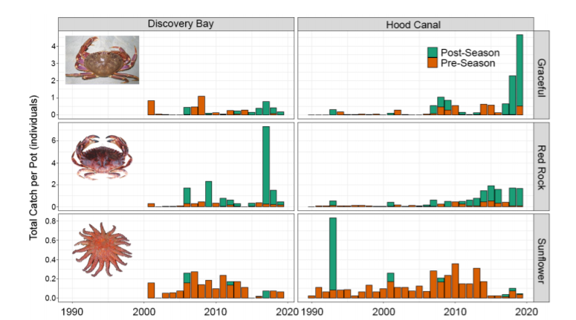
Figure 4. Washington Department of Fish and Wildlife crustacean test fishery results for graceful and red rock crab catch (top 2 panels) and Pycnopodia helianthoides sunflower sea star bycatch in crab pots (bottom panel in the Hood Canal region of Puget Sound, WA). Figure by Taylor Frierson. Source: Gravem 2021
There is some commercial trade of sunflower sea stars. Records of sunflower sea star trade are incomplete because records are not identified by species. There are commercial sales of dried sunflower sea stars for collectors and décor. Online retailers advertise sunflower sea stars or Pycnopodia. Because of the sea star’s current imperiled status, harvest and sales of sunflower sea stars threatens their continued existence.

Disease or predation
Disease is the primary driver of extinction for the sunflower sea star. As many as 5.75 billion sunflower sea stars have been killed by disease in the last decade. Sea star wasting disease is considered the largest marine disease to affect non-commercial species. Scientist Joe Gaydos referred to the epizootic as an “underwater zombie apocalypse.”
Sea star wasting disease has broken out in 20 species of sea stars in the northeastern Pacific, and it has decimated the global population of sunflower sea stars. Between 2013 to 2017, sea star wasting disease caused a severe sunflower sea star population crash. Sunflower sea stars throughout their range were affected, resulting in a 90.6 percent population decline.
Sunflower sea stars afflicted by sea star wasting disease suffer from abnormally twisted arms, white lesions, loss of body tissue, arm loss, melting, and death. Sea star wasting disease severely affects sunflower sea stars, and it has decimated the population. Some local populations were extirpated within a matter of weeks, such as the northern Channel Islands. Other populations have undergone significant declines, and there are concerns that remaining sunflower sea stars are too rare for successful reproduction since they rely on aggregation for broadcast spawning.
Surveys from California to Alaska reveal 80 to 100 percent declines across the sunflower sea star’s range due to sea star wasting disease outbreaks between 2013 and 2017. Researchers noted that the significant population crashes also coincided with anomalous sea surface warming periods.
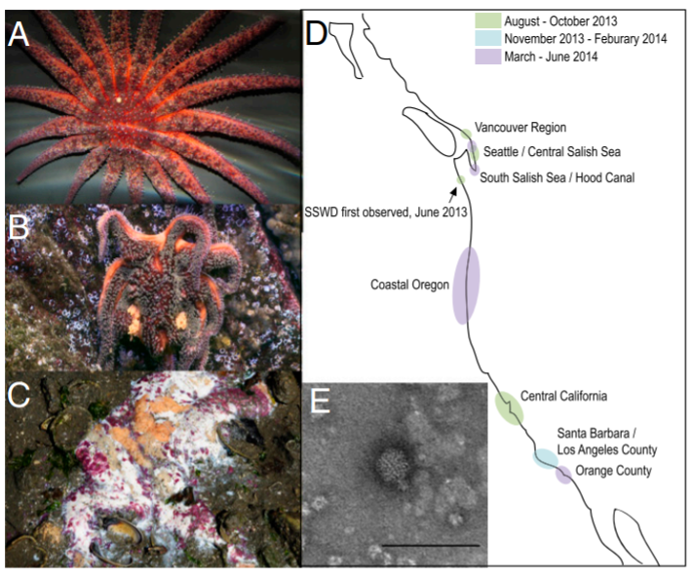
Figure 5. Photographs of SSWD-affected stars (A) asymptomatic P. helianthoides, (B) symptomatic P. helianthoides, and (C) symptomatic P. ochraceus. Disease symptoms are consistent with loss of turgor, loss of rays, formation of lesions, and animal decomposition. (D) Map showing occurrence of SSWD based on first reported observation. (E) Transmission electron micrograph of negatively stained (uranyl acetate) viruses extracted from an affected wild E. troschelii from Vancouver. The sample contained 20–25-nm diameter nonenveloped icosohedral viral particles on a background of cellular debris (primarily ribosomal subunits) and degraded viral particles of similar morphology. (Scale bar: 100 nm.) Source: Hewson 2014.
Sea star wasting disease is believed to be caused by a densovirus (parvoviridae). It travels through currents and spreads to different regions. Researchers exposed healthy sea stars to the densovirus, which transmitted the disease.
Subsequent studies, however, have determined that the disease is more complex. A number of factors ranging from environmental stressors to the microbe biome in the sea stars may play a role. Sea stars experienced a shift in their microbe biome as they became more diseased, and scientists believe that some imbalance of the microbe biome may lead to infection or other pathogens. A recent study indicated that the disease is related to the animal’s inability to get oxygen. Ocean warming has also been linked to hastened disease progression and severity.
Usually, sea star wasting disease results in degradation and death of the animals. Diseased sunflower sea stars lose tissue and have low metabolic activity. Oddly, the animals’ immune genes do not respond to the disease. This means that few sea stars recover and the disease has had a devastating impact on sunflower sea star populations.

Other natural or manmade factors affecting sunflower sea star’s continued existence
Climate change is a key threat to the sunflower sea star because it has contributed to the severity of sea star wasting disease, which has decimated the entire population. Studies have found that sunflower sea star population crashes from sea star wasting disease coincided with anomalous warming. Warm sea surface temperature anomalies have been associated with lower abundance of sunflower sea stars. Additionally, sea level rise and ocean acidification threaten sunflower sea stars.
An overwhelming international scientific consensus has established that human-caused climate change is already causing widespread harms and that climate change threats are becoming increasingly dangerous. The Intergovernmental Panel on Climate Change (“IPCC”), the international scientific body for the assessment of climate change, concluded in its 2014 Fifth Assessment Report that: “[w]arming of the climate system is unequivocal, and since the 1950s, many of the observed changes are unprecedented over decades to millennia. The atmosphere and ocean have warmed, the amounts of snow and ice have diminished, and sea level has risen,” and further that “[r]ecent climate changes have had widespread impacts on human and natural systems.”

The U.S. federal government has repeatedly recognized that human-caused climate change is causing widespread and intensifying harms across the country in the authoritative National Climate Assessments, scientific syntheses prepared by hundreds of scientific experts and reviewed by the National Academy of Sciences and federal agencies. Most recently, the Fourth National Climate Assessment, comprised of the 2017 Climate Science Special Report (Volume I) and the 2018 Impacts, Risks, and Adaptation in the United States (Volume II), concluded that “there is no convincing alternative explanation” for the observed warming of the climate over the last century other than human activities. It found that “evidence of human-caused climate change is overwhelming and continues to strengthen, that the impacts of climate change are intensifying across the country, and that climate-related threats to Americans’ physical, social, and economic well-being are rising.”

Global average surface temperatures have risen by 1.8°F (1.0°C) since 1901, most of which occurred during the past three decades. As of 2018, 16 of the last 17 years were the warmest ever recorded by human observations. Global average temperature reached a record high in 2016, which scientists determined was “only possible” because of anthropogenic climate change, with 2017 ranked as the second hottest year on record.

The United States warmed by 1.8°F (1.0°C) between 1901 and 2016, with the most rapid warming occurring after 1979. The U.S. is expected to warm by an additional 2.5°F (1.4°C), on average, by mid-century relative to 1976-2005, and record-setting hot years will become commonplace. By late century, much greater warming is projected, ranging from 2.8 to 7.3°F (1.6 to 4.1°C) under a lower emissions scenario and 5.8 to 11.9°F (3.2 to 6.6°C) under a higher emissions scenario, with the largest increases in the upper Midwest and Alaska. This year there was a Pacific Northwest heatwave with temperatures spiking above 100 degrees that would have been impossible without climate change. Scientists noted that greenhouse gas emissions made the heatwave 150 times more likely. The heatwave is predicted to result in massive a marine life die off—cooking animals in its path.

Large-scale marine heatwaves have increased more than 20-fold due to anthropogenic climate change. These marine heatwaves cause major disruption in ocean ecosystems. Between 2014 and 2016, a massive marine heatwave that was called “the blob” struck the Pacific Coast. The persistent high temperature anomaly reached more than 6 degrees above normal sea surface temperatures in southern California. For example, they have contributed to mortality of sea birds, marine mammals and salmon in the Pacific Northwest. Importantly, the California Current blob was linked to the severity and spread of sea star wasting disease that decimated sunflower sea star populations. Marine heatwaves are also associated with invertebrate spawning failures.

The world’s oceans have absorbed more than 90 percent of the excess heat caused by greenhouse gas warming, resulting in average sea surface warming of 1.3°F (0.7°C) per century since 1900. A 2019 study estimated that oceans are warming 40 percent faster than scientists projected, and that the rate of ocean warming is accelerating. Rapid warming of the oceans has widespread impacts and has contributed to increases in rainfall intensity, rising sea levels, the destruction of coral reefs, declining ocean oxygen levels, and ice loss from glaciers, ice sheets and polar sea ice. Global average sea surface temperature is projected to rise by 4.9°F (2.7°C) by the end of the century under a higher emissions scenario, with even greater warming in the coastal waters of the Northeastern U.S. and Alaska.

Sea level rise also threatens sunflower sea stars that inhabit the sub and intertidal zones. As sea levels rise, there will be reduced habitat for sea stars and they will encounter shoreline armoring and other development that prevents the upland expansion of habitat. The Fourth National Climate Assessment estimated that global sea level is very likely to rise by 1.0 to 4.3 feet by the end of the century relative to the year 2000, with sea level rise of 8.2 feet possible. Sea level rise will be much more extreme without strong action to reduce greenhouse gas pollution. By the end of the century, global mean sea level is projected to increase by 0.8 to 2.6 feet under a lower emissions RCP 2.6 scenario, compared with 1.6 to 6 feet under a high emissions RCP 8.5 scenario. The impacts of sea level rise will be long-lived: under all emissions scenarios, sea levels will continue to rise for many centuries.

Sunflower sea stars are threatened by ocean acidification. The global oceans have absorbed more than a quarter of the CO₂ emitted to the atmosphere by human activities, which has significantly increased the acidity of the surface ocean. Ocean acidification has reduced the availability of key chemicals—aragonite and calcite—that many marine species use to build their shells and skeletons. The ocean’s absorption of anthropogenic CO₂ has already resulted in more than a 30 percent increase in the acidity of ocean surface waters, at a rate likely faster than anything experienced in the past 300 million years. Ocean acidity could increase by 150 percent by the end of the century if CO₂ emissions continue unabated. In the United States, the West Coast, Alaska, and the Gulf of Maine are experiencing the earliest, most severe changes due to ocean acidification.

Ocean acidification negatively affects a wide range of marine species by hindering the ability of calcifying marine creatures like corals, oysters, and crabs to build protective shells and skeletons and by disrupting metabolism and critical biological functions. The adverse effects of ocean acidification are already being observed in wild populations, including severe shell damage to pteropods (marine snails at the base of the food web) along the U.S. west coast, reduced coral calcification rates in reefs worldwide, and mass die-offs of larval Pacific oysters in the Pacific Northwest. An expert science panel concluded in 2016 that “growth, survival and behavioral effects linked to OA [ocean acidification] extend throughout food webs, threatening coastal ecosystems, and marine-dependent industries and human communities.”

Sunflower sea stars are threatened by ocean acidification because it inhibits growth and development of juvenile and larval sea stars. A synthesis of 41 scientific studies on the impacts of ocean acidification on echinoderms in the California Current Ecosystem demonstrated broad ranging adverse effects. Ocean acidification affects larval and adult echinoderms, impairing their growth, development, behavior, physiology, and survival. While the review found variability in responses to ocean acidification, it determined the most sensitivity in early life stages that could be a bottleneck for the survival of the sunflower sea star. Some individual studies have determined that echinoderms are more sensitive to ocean acidification. For example, in studies echinoderm impacts to ocean acidification brittle stars showed slowed metabolism, 80 percent decrease in arm regeneration, and slower larval development of common sea stars.

The inadequacy of existing regulatory mechanisms
The threat of sea star wasting disease to sunflower sea stars continues. Despite the recovery of some sea stars since the 2013 outbreak, sunflower sea stars have not rebounded. While the 2013 outbreak was the most widespread epizootic, prior sea star wasting disease outbreaks have been more spatially and temporally limited. Hence the threat of another disease outbreak is possible, particularly as it has been linked to climate change.
Regulatory mechanisms are inadequate to address the threat of disease to the sunflower sea star. There are currently no regulatory mechanisms to abate the disease threat. Treatments have been thus far ineffective, and significant data gaps inhibit regulatory mechanisms to prevent disease or spur recovery.
Because ocean warming also contributes to the endangerment of sunflower sea star, the inadequacy of regulatory mechanisms to address climate change also indicate that listing may be warranted.
The existing national and international regulatory mechanisms do not adequately protect the sunflower sea star from the existential threat posed by climate change. These mechanisms are non-binding and, even if adhered to by all parties, fail to mandate greenhouse gas emission reductions sufficient to protect the sunflower sea star from climate change-related effects including ocean warming, ocean acidification, and disease.
The Service has repeatedly acknowledged that regulatory mechanisms are inadequate to regulate greenhouse gas emissions at levels protective of species. For example, in its proposed listing rule for the bearded seal, the Service stated that
there are currently no effective mechanisms to regulate [greenhouse gas (GHG)] emissions, which are contributing to global climate change and associated modifications to bearded seal habitat. The risk posed to bearded seals due to the lack of mechanisms to regulate GHG emissions is directly correlated to the risk posed by the effects of these emissions.
In a recent synthesis of the literature on point, the Service stated that “existing regulatory mechanisms with the objective of reducing GHG emissions were inadequate to prevent … climate-related threats.” The Service conducted “an in-depth analysis of international agreements to curb GHG emissions and their respective progress” and concluded that it was “unlikely that Parties would be able to collectively achieve, in the near term, climate change avoidance goals outlined via international agreements.” In addition, “none of the major global initiatives appeared to be ambitious enough, even if all terms were met, to reduce GHG emissions to the level necessary to” avoid impacts to imperiled species.
As detailed below, the continued failure of the U.S. government and the international community to implement effective and comprehensive greenhouse gas reduction measures places sunflower sea stars at ever-increasing risk of extinction. Both international and national climate change regulatory mechanisms are insufficient to prevent the extinction of sunflower sea stars.
First, international climate change agreements are insufficient to protect sunflower sea star from the perilous effects of climate change. The primary international agreement on climate action is the United Nations Framework Convention on Climate Change (UNFCCC). Adopted at the Rio Earth Summit in 1992, it has to date been ratified by 195 countries. The most recent agreement covering UNFCCC countries, the Paris Agreement, was ratified in 2016 and has just begun to take effect. According to the UNFCCC,
[t]he Paris Agreement builds upon the Convention and for the first time brings all nations into a common cause to undertake ambitious efforts to combat climate change and adapt to its effects.
The “central aim” of the Agreement “is to strengthen the global response to the threat of climate change by keeping a global temperature rise this century well below 2 degrees Celsius above pre-industrial levels and to pursue efforts to limit the temperature increase even further to 1.5 degrees Celsius.”
Scientists predict increases of 2°C or more would result in “‘dangerous’ [to] ‘extremely dangerous’ climate change.” Projected impacts include the disappearance of Arctic summer sea ice, irreversible melting of the Greenland ice sheet, an increased risk of extinction for 20-30% of species on Earth, and “rapid and terminal” declines of coral reefs worldwide. The Paris Agreement seeks to avoid such dangerous harms by aiming to limit warming to 1.5°C. Humans already have warmed the planet 1.0°C over the pre-industrial level, and at the current rate we likely will reach 1.5°C of warming between 2030 and 2052.
This warming occurs largely due to rising atmospheric CO₂ levels. This year, the global annual atmospheric concentration of CO₂ exceeded 418 parts per million (ppm) for the first time. This carbon dioxide level—a dramatic increase over the preindustrial level of 280 ppm—has not been seen for 3 million years. Atmospheric CO₂ has been rising at a rate of nearly 3 ppm per year, and this rate is accelerating. But as climate scientists have warned: “[i]f humanity wishes to preserve a planet similar to that on which civilization developed and to which life on Earth is adapted, paleoclimate evidence and ongoing climate change suggest that CO₂ will need to be reduced … to at most 350 ppm [equivalent to ~1.5°C], but likely less than that.” This 350 ppm target must be achieved within decades to prevent dangerous tipping points and “the possibility of seeding irreversible catastrophic effects.”
Despite its adoption of the 1.5°C threshold, the Paris Agreement does not do enough to shield the sunflower sea star from the harmful effects of climate change, including impacts to its one of its primary habitats: coral reefs. See Part III.1.A, supra. Additionally, signatories have not yet effected the changes necessary to achieve the Agreement’s goals. Finally, the withdrawal of the United States—one of the world’s primary contributors of atmospheric CO₂—from the Paris Agreement will hamper global efforts to rein in the devastating effects of climate change.
Second, national climate change law is also insufficient to protect the sunflower sea star. To date, federal agencies have failed to fully capitalize on existing authority under domestic law to reduce greenhouse gas emissions to levels that would be protective of species. The U.S. government repeatedly has acknowledged that its rules do not go far enough to notably reduce the nation’s greenhouse gas emissions. The government’s failure to fully use existing laws such as the Clean Air Act and Energy Policy and Conservation Act to force needed greenhouse gas reductions renders them inadequate mechanisms to protect the sunflower sea stars and its habitat from the effects of climate change.
A 2018 IPCC report makes clear that greenhouse gas emissions must be halved in the next decade to avoid the most devastating consequences of climate change. The report concludes that pathways to limit warming to 1.5°C with little or no overshoot require “a rapid phase out of CO₂ emissions and deep emissions reductions in other GHGs and climate forcers.” In pathways consistent with limiting warming to 1.5°C, global net anthropogenic CO₂ emissions must decline by about 45 percent from 2010 levels by 2030, reaching net zero around 2050. For a two-thirds chance for limiting warming to 1.5°C, CO₂ emissions must reach net zero in 25 years. The IPCC report provides overwhelming scientific evidence for the necessity of immediate, deep greenhouse gas reductions across all sectors to avoid devastating climate change-driven damages, and underscores the high costs of inaction or delays, particularly in the next crucial decade, in making these cuts.

However, several studies show that existing regulatory mechanisms are not on track to steeply cut emissions. For example, a 2016 global analysis found that the carbon emissions that would be released from burning the oil, gas, and coal in the world’s currently operating fields and mines would fully exhaust and exceed the carbon budget consistent with staying below 1.5°C. The reserves in currently operating oil and gas fields alone, even excluding coal mines, would likely lead to warming beyond 1.5°C. A 2019 analysis underscored that the United States must halt new fossil fuel extraction and rapidly phase out existing production to avoid jeopardizing our ability to meet the Paris climate targets and avoid the worst dangers of climate change.

Additionally, according to the United Nations’ November 2019 “Emissions Gap” report, if the world is to limit global warming to 1.5°C, countries must cut emissions by at least 7.6 percent per year over the next decade, for a total emissions reduction of 55 percent between 2020 and 2030. Moreover, the Energy Information Administration’s Annual Energy Outlook for 2020 indicates that without a rapid transition away from fossil fuels, annual U.S. greenhouse gas emissions are projected to begin rising again by the 2030s.

Critical habitat and protective regulations
The ESA mandates that, when the Service lists a species as endangered or threatened, the agency must also concurrently designate critical habitat for that species. 16 U.S.C. § 1533(a)(3)(A)(i); see also id. at § 1533(b)(6)(C). The ESA defines “critical habitat” as:

i. the specific areas within the geographical area occupied by the species, at the
time it is listed . . . , on which are found those physical or biological features (I)
essential to the conservation of the species and (II) which may require special
management considerations or protection; and

ii. specific areas outside the geographical area occupied by the species at the time
it is listed … , upon a determination by the Secretary that such areas are
essential for the conservation of the species.

Id. at § 1532(5)(A). The Center expects that the Service will comply with this unambiguous mandate and designate critical habitat concurrently with the listing of the sunflower sea star. Critical habitat must include, but should not necessarily be limited to, the intertidal and subtidal sunflower sea star habitat off Alaska, Washington, Oregon, and California.

Should the Service determine after conducting a status review that listing of the sunflower sea star as “threatened” is warranted, the Center hereby petitions the agency to simultaneously issue a 4(d) rule outlining necessary and advisable regulations for the species’ conservation.
The Center urges the Service to extend to the sunflower sea star all prohibitions of ESA Section 9, including the bans on taking, imports, exports, sale in interstate or foreign commerce, and transport (applying the existing limited exceptions to promote science and restoration as provided in ESA Section 10) and to promulgate additional protective regulations needed for survival and recovery of the sunflower sea star.

Conclusion
Sunflower sea stars are a fantastic and beautiful keystone species of the Pacific Coast. Their conservation is essential to maintain the health of the rich kelp forests and wildlife that inhabit them. Sunflower sea stars have been decimated by sea star wasting disease, urgent action is needed to prevent their extinction. We urge the Service to promptly list the sunflower sea star as endangered or threatened because they need the safety net of protections offered by the ESA.

Gravem, Sarah A., et al., Pycnopodia helianthoides. IUCN Red List of Threatened Species (2021).
Gravem 2021.
McGaw, Iain J. and Twitchit, Tabitha A., Specific dynamic action in the sunflower star, Pycnopodia helianthoides, 161 Comparative Biochemistry and Physiology, Part A 287–95 (2012).
Gravem 2021.
Gravem 2021.
Gravem 2021.
McGaw 2012.
Brewer, Reid, Konar, Brenda, Chemosensory responses and foraging behavior of the seastar Pycnopodia helianthoides, 147 Marine Biology 789 (2005).
Brewer 2005.
Montecino-Latorre, Diego, et al. Devastating Transboundary Impacts of Sea Star Wasting Disease on Subtidal Asteroids. 11 PLoS ONE e0163190 (2016).
Shultz, Jessica A., et al., Evidence for a trophic cascade on rocky reefs following sea star mass mortality in British Columbia, 4 PeerJ 1980 (2016).
Burt, Jenn M., et al., Sudden collapse of a mesopredator reveals its complementary role in mediating rocky reef regime shifts 285 Proc. R. Soc. B. 20180553 (2018).
Burt 2018.
McGaw 2012.
Monterey Bay Aquarium. Sunflower star (Pycnopodia helianthoides), https://www.montereybayaquarium.org/animals/animals-a-to-z/sunflower-star
Shivji, M. et al. Feeding and Distribution Study of the Sunflower Sea Star Pycnopodia helianthoides (Brandt, 1835), 37 Pacific Science 133-40 (1983).
Id.
McGaw 2012.
Shivji 1983.
Gravem 2021.
Montecino-Latorre 2016.
Id.
Harvell, C.D., et al. Disease epidemic and a marine heat wave are associated with the continental-scale collapse of a pivotal predator (Pycnopodia helianthoides), 5 Science Advances eaau7042 (2019).
Harvell 2019.
Harvell 2019.
Gravem 2021.
Eisaguirre, Jacob H., et al. Trophic redundancy and predator size class structure drive differences in kelp forest ecosystem dynamics, 101 Ecology e02993 (2020).
Gravem, Sarah, et al. Research and Management Priorities to Address Sea Star Wasting Syndrome: A Collaborative Strategic Action Plan (Nov. 2018).
Gravem 2021.
Gravem 2021.
IUCN 2001. IUCN Red List Categories and Criteria: Version 3.1.
Id.
Id. § 1532(6).
Id. § 1532(20).
Id. § 1533(a).
Id. § 1533(b)(1)(A).
Gravem 2021.
Gravem 2021.
Gravem 2021.
Gravem 2021.
Suchanek, Thomas H., Temperate Coastal Marine Communities: Biodiversity and Threats, 34 Amer. Zool. 100-114 (1994).
Halpern, Benjamin S., et al. Mapping cumulative impacts to California Current marine ecosystems, 2 Conservation Letters 138-48 (2009).
Brophy Laura S., et al., Insights into estuary habitat loss in the western United States using a new method for mapping maximum extent of tidal wetlands. 14(8) PLoS ONE e0218558 (2019).
Gittman, Rachel K., Engineering away our natural defenses: an analysis of shoreline hardening in the US, 13(6) Front. Ecol. Environ. 301-07(2015).
Gittman 2015.
Dethier, Megan N. et al., Multiscale impacts of armoring on Salish Sea shorelines: Evidence for cumulative and threshold effects, 175 Estuarine, Coastal and Shelf Science 106-17 (2016).
Griggs, Gary B. The Effects of Armoring Shorelines—The California Experience 2010, in Shipman, H., et al., eds., Puget Sound Shorelines and the Impacts of Armoring—Proceedings of a State of the Science Workshop, May 2009: U.S. Geological Survey Scientific Investigations Report 77-84 (2010).
Jurgens, Laura J., et al, Patterns of Mass Mortality among Rocky Shore Invertebrates across 100 km of Northeastern Pacific Coastline, 10(6) PLoS ONE e0126280 (2015).
Pelletier, E., & Larocque, R., Bioaccumulation of mercury in starfish from contaminated mussels, 18(9) Marine Pollution Bulletin 482–85 (1987); Deidda, I.; et al., Neurotoxicity in Marine Invertebrates: An Update, 10 Biology 161 (2021).
Puritz, Jonathan, and Toonen, Robert, Coastal pollution limits pelagic larval dispersal, 2 Nature Communications 226 (2011).
Courtene-Jones, W., et al., Microplastic pollution identified in deep-sea water and ingested by benthic invertebrates in the Rockall Trough, North Atlantic Ocean, 231 Environmental Pollution 271–80 (2017).
Gravem 2021.
Gravem 2021
Gravem 2021.
Gravem 2021.
Gravem 2021.
Nair, Roshini, 5.7B sunflower sea stars have died in past decade, bringing species to brink of extinction, CBC News (Dec. 16, 2020), https://www.cbc.ca/news/canada/british-columbia/sunflower-sea-star-decline-1.5844674.
Montecino-Latorre 2016.
Research2Reality, There Were Arms Walking Off By Themselves (June 20, 2019), https://research2reality.com/energy-environment-nature/creatures/sea-star-wasting-disease-climate-change/.
Gravem 2021.
Fuess, Lauren E., Up in Arms: Immune and Nervous System Response to Sea Star Wasting Disease, 10(7) PLoS ONE e0133053 (2015).
Montecino-Latorre 2016.
Jurgens 2015; Gravem 2021; Eisaguirre 2020.
Gravem 2021.
Harvell 2019.
Harvell 2019.
Hewson, Ian, et al., Densovirus associated with sea-star wasting disease and mass mortality, 111 PNAS 17278-83 (2014); Hewson, I., et al., Investigating the Complex Association Between Viral Ecology, Environment, and Northeast Pacific Sea Star Wasting, 5 Front. Mar. Sci. 77 (2018).
Gravem 2018.
Hewson 2014.
Konar, Brenda, et al., Wasting disease and static environmental variables drive sea star assemblages in the Northern Gulf of Alaska, 520 Journal of Experimental Marine Biology and Ecology 151209 (2019).
Lloyd, Melanie M. and Pespeni, Melissa H., Microbiome shifts with onset and progression of Sea Star Wasting Disease revealed through time course sampling, 8 Scientific Reports 16476 (20180.
Aquino Citalli A, et al., Evidence That Microorganisms at the Animal-Water Interface Drive Sea Star Wasting Disease, 11 Front. Microbiol. 610009 (2021).
Gravem 2018.
Gudenkauf BM, and Hewson, Ian, Metatranscriptomic Analysis of Pycnopodia helianthoides (Asteroidea) Affected by Sea Star Wasting Disease, 10(5) PLoS ONE e0128150 (2015).
Gudenkauf 2015.
Harvell 2019.
Harvell 2019.
Intergovernmental Panel on Climate Change, Climate Change 2014: Synthesis Report. Contribution of Working Groups I, II and III to the Fifth Assessment Report of the Intergovernmental Panel on Climate Change (2014) at 2.
U.S. Global Change Research Program, Climate Science Special Report: Fourth National Climate Assessment, Vol. I (2017), https://science2017.globalchange.gov/.
U.S. Global Change Research Program, Impacts, Risks, and Adaptation in the United States, Fourth National Climate Assessment, Volume II (2018).
U.S. Global Change Research Program, Climate Science Special Report: Fourth National Climate Assessment, Vol. I (2017), https://science2017.globalchange.gov/ at 10.
U.S. Global Change Research Program, Impacts, Risks, and Adaptation in the United States, Fourth National Climate Assessment, Volume II (2018) at 36.
Id. at 13.
U.S. Global Change Research Program, Impacts, Risks, and Adaptation in the United States, Fourth National Climate Assessment, Volume II (2018) at 76.
Knutson, Thomas R. et al., CMIP5 model-based assessment of anthropogenic influence on record global warmth during 2016, 99 Bulletin of the American Meteorological Society S11 (2017).
National Aeronautics and Space Administration, Long-term warming trend continued in 2017: NASA, NOAA, Release 18-003, January 18, 2018, https://www.nasa.gov/press-release/long-term-warming-trend-continued-in-2017-nasa-noaa
U.S. Global Change Research Program, Climate Science Special Report: Fourth National Climate Assessment, Vol. I (2017), https://science2017.globalchange.gov/ at 17.
Id. at 11.
Id. at 17. Id. at 17 and 136: The high emissions scenario RCP 8.5 corresponds to a rise of CO₂ levels from the current-day 400 ppm up to 936 ppm by the end of this century. The lower emissions scenarios RCP4.5 and RCP 2.6 correspond to atmospheric CO₂ levels remaining below 550 and 450 ppm by 2100, respectively. These scenarios are numbered according to change in radiative forcing by 2100: +2.6, +4.5, +8.5 watts per square meter (W/m²).
Id. at Figure ES.4.
Cappucci, Matthew, Pacific Northwest heat wave was ‘virtually impossible’ without climate change, scientists find, Wash. Post (July 7, 2021), https://www.washingtonpost.com/weather/2021/07/07/pacific-northwest-heat-wave-climate/.
World Weather Attribution, Western North American extreme heat virtually impossible without human-caused climate change (July 7, 2021), https://www.worldweatherattribution.org/western-north-american-extreme-heat-virtually-impossible-without-human-caused-climate-change/.
Einhorn, Catrin, Like in ‘Postapocalyptic Movies’: Heat Wave Killed Marine Wildlife en Masse, NY Times (July 9, 2021), https://www.nytimes.com/2021/07/09/climate/marine-heat-wave.html.
Laufkötter, Charlotte, et al., High-impact marine heatwaves attributable to human-induced global warming, 369 Science 1621–1625 (2020).
Gentemann, C. L., M. R. Fewings, and M. García-Reyes, Satellite sea surface temperatures along the West Coast of the United States during the 2014–2016 northeast Pacific marine heat wave,44 Geophys. Res. Lett. 312–319 (2017).
Frölicher, Thomas L. and Charlotte Laufkötte, Emerging risks from marine heat waves, 9 Nature Communications 650 (2018).
Cudmore, Becca, Striking While the Water Is Warm, Hakai Magazine (May 20, 2015); https://www.hakaimagazine.com/news/striking-while-water-warm/.
Shanks, Alan L., et al., Marine heat waves, climate change, and failed spawning by coastal invertebrates, 9999 Liminology and Oceanography 1-10 (2019).
U.S. Global Change Research Program, Climate Science Special Report: Fourth National Climate Assessment, Vol. I (2017), https://science2017.globalchange.gov/ at 364, 367.
Cheng, Lijing et al., How fast are the oceans warming?, 363 Science 128 (2019).
Id.
U.S. Global Change Research Program, Climate Science Special Report: Fourth National Climate Assessment, Vol. I (2017), https://science2017.globalchange.gov/ at 368.
Thorne, Karen, et al., U.S. Pacific coastal wetland resilience and vulnerability to sea-level rise, 4 Science Advances eaao3270 (2018).
Id. at 74, 487, 758.
U.S. Global Change Research Program, Climate Science Special Report: Fourth National Climate Assessment, Vol. I (2017), https://science2017.globalchange.gov/ at 344.
Melillo, Jerry M. et al. (eds.), Climate Change Impacts in the United States: The Third National Climate Assessment, U.S. Global Change Research Program (2014), https://www.globalchange.gov/browse/reports/climate-change-impacts-united-states-third-national-climate-assessment-0 at 45. Also U.S. Global Change Research Program, Climate Science Special Report: Fourth National Climate Assessment, Vol. I (2017), https://science2017.globalchange.gov/ at 345–346.
U.S. Global Change Research Program, Climate Science Special Report: Fourth National Climate Assessment, Vol. I (2017), https://science2017.globalchange.gov/ at 371–372.
Hönisch, Barbel et al., The geological record of ocean acidification, 335 Science 1058 (2012); U.S. Global Change Research Program, Climate Science Special Report: Fourth National Climate Assessment, Vol. I (2017), https://science2017.globalchange.gov/ at 372, 374.
Orr, James C. et al., Anthropogenic ocean acidification over the twenty-first century and its impact on calcifying organisms, 437 Nature 681 (2005); Feely, Richard et al., Ocean acidification: Present conditions and future changes in a high CO₂ world, 22 Oceanography 36 (2009).
Feely, Richard A. et al., Evidence for upwelling of corrosive ‘acidified’ water onto the continental shelf, 320 Science 1490 (2008); Ekstrom, Julia A. et al., Vulnerability and adaptation of U.S. shellfisheries to ocean acidification, 5 Nature Climate Change 207 (2015); Mathis, Jeremy T. et al., Ocean acidification in the surface waters of the Pacific-Arctic boundary regions, 28 Oceanography 122 (2015); Mathis, Jeremy T. et al., Ocean acidification risk assessment for Alaska’s fishery sector, 136 Progress in Oceanography 71 (2015); Chan, F. et al., The West Coast Ocean Acidification and Hypoxia Science Panel: Major Findings, Recommendations, and Actions, California Ocean Science Trust (April 2016).
Fabry, Victoria J. et al., Impacts of ocean acidification on marine fauna and ecosystem processes, 65 ICES Journal of Marine Science 414 (2008); Kroeker, Kristy J. et al., Impacts of ocean acidification on marine organisms: quantifying sensitivities and interactions with warming, 19 Global Change Biology 1884 (2013).
Bednaršek, N. et al., Limacina helicina shell dissolution as an indicator of declining habitat suitability owing to ocean acidification in the California Current Ecosystem, 281 Proceedings of the Royal Society B 20140123 (2014).
Albright, Rebecca et al., Reversal of ocean acidification enhances net coral reef calcification, 531 Nature 362 (2016).
Barton, Alan et al., The Pacific oyster, Crassostrea gigas, shows negative correlation to naturally elevated carbon dioxide levels: Implications for near-term ocean acidification effects, 57 Limnology and Oceanography 698 (2012).
Chan, Francis et al., The West Coast Ocean Acidification and Hypoxia Science Panel: Major Findings, Recommendations, and Actions, California Ocean Science Trust, Oakland, California, USA (April 2016) at 4.
Bednarsek 2021.
Bednarsek 2021.
Bednarsek 2021.
Byrne, Maria, & Przeslawski, Rachel, Multistressor impacts of warming and acidification of the ocean on marine invertebrates’ life histories.53(4) Integrative and Comparative Biology 582–596 (2013); Kroeker, K.J., et al., Impacts of ocean acidification on marine organisms: quantifying sensitivities and interaction with warming, 19 Glob Change Biology 1884–1896 (2013); Wittmann, A. C., & Pörtner, H. O., Sensitivities of extant animal taxa to ocean acidification, 3(11) Nature Clim Change 995–1001 (2013); Przeslawski, R., Byrne, M. and Mellin, C., A review and meta-analysis of the effects of multiple abiotic stressors on marine embryos and larvae, 21 Glob Change Biol. 2122–2140 (2015).
Hu, Marian, et al., Trans‐life cycle acclimation to experimental ocean acidification affects gastric pH homeostasis and larval recruitment in the sea star Asterias rubens, Acta Physiol. e13075 (2018); Hu, Marian, et al., Energy metabolism and regeneration are impaired by seawater acidification in the infaunal brittlestar Amphiura filiformis. 217 J. Exp. Biol. 2411‐2421 (2014).
Gravem 2018; Gudenkauf 2015).
See e.g., Wahlstrom, Sarah, et al., Efficacy of Intracoelomic Enrofloxacin for the Treatment of Sea Star Wasting Disease in Four Species of Captive Asteroidea (Abstract), IAAAM (2015), https://www.vin.com/apputil/content/defaultadv1.aspx?id=6651412&pid=12676.
75 Fed. Reg. 77,496, 77,508 (Dec. 10, 2010); see also 77 Fed. Reg. 76,706, 76,712 (Dec. 28, 2012) (noting that “[c]urrent mechanisms do not effectively regulate GHG emissions, which are contributing to global climate change and associated modifications to ringed seal habitat.”).
79 Fed. Reg. 53,852, 53,903 (Sept. 10, 2014).
Id.
Id.
United Nations Framework Convention on Climate Change (UNFCCC), The Paris Agreement (2015).
Id.
Anderson, Kevin, and Bows, Alice, Beyond ‘dangerous’ climate change: emission scenarios for a new world, 369 Phil. Trans. R. Soc. 20–44 (2011).
Veron, J.E.N. et al., The coral reef crisis: the critical importance of <350 ppm CO2, 58 Marine Pollution Bull. 1428 (2009); see also Jones, Chris, et al., Committed terrestrial ecosystem changes due to climate change, 2(7) Nature Geoscience 484–487 (2009); The Economics of Ecosystems and Biodiversity (TEEB), Climate Issues Update (Sept. 2009); Hare, W. et al., Climate hotspots: key vulnerable regions, climate change and limits to warming, 11 Regional Envt’l Change 1 (2011); Warren, R. et al., Increasing impacts of climate change upon ecosystems with increasing global mean temperature rise, 106 Climatic Change 141 (2011); Frieler, K. et al., Limiting global warming to 2°C is unlikely to save most coral species, 3 Nature Climate Change 165 (2012).
IPCC (2018); UNFCCC (2020).
NOAA, Global Monitoring Laboratory, Trends in Atmospheric Carbon Dioxide (last visited Aug. 4, 2021), https://gml.noaa.gov/ccgg/trends/.
Id.
Raupach, M. R., et al., Global and regional drivers of accelerating CO2 emissions, 104(24) Proceedings of the National Academy of Sciences, 10288–10293 (2017); Friedlingstein, P., et al., Update on CO2 emissions, 3 Nature Geosci 811–812 (2010), https://doi.org/10.1038/ngeo1022; Harvey, Chelsea, Atmospheric CO2 Breaks a Record. Here’s Why It Matters, E&E News (May 16, 2019); Nat’l Oceanic & Atmospheric Admin. (NOAA), Global carbon dioxide growth in 2018 reached 4th highest on record (2019), https://www.noaa.gov/news/global-carbon-dioxide-growth-in-2018-reached-4th-highest-on-record (last updated March 22, 2019).
Hansen, J.M. et al., Target atmospheric CO2: where should humanity aim?, 2 Open Atmospheric Sci. J. 217 (2008).
Id.
See United Nations Environment Programme (UNEP), Emissions Gap Report, UNEP, Nairobi (2019), https://www.unep.org/resources/emissions-gap-report-2019.
See id.
See generally id.
See, e.g., Nat’l Highway Traffic Safety Admin (NHTSA), Medium- and Heavy-Duty Fuel Efficiency Improvement Program, Final Environmental Impact Statement (June 2011) (“these reductions in emissions are not sufficient by themselves to reduce total [commercial medium-heavy duty on-highway vehicle and work truck] emissions below their 2005 levels by 2020”); 77 Fed. Reg. 22,392, 22,401 (April 13, 2012) (conceding that this new power plant rule on greenhouse gas emissions “will not have direct impact on U.S. emissions of greenhouse gases under expected economic conditions”).
Intergovernmental Panel on Climate Change, Global Warming of 1.5°C, An IPCC special report on the impacts of global warming of 1.5°C above pre-industrial levels and related global greenhouse gas emission pathways, in the context of strengthening the global response to the threat of climate change, sustainable development, and efforts to eradicate poverty (2018). at 2-28.
Id. at SPM-15.
Id.
Oil Change International, The Sky’s Limit: Why the Paris Climate Goals Require a Managed Decline of Fossil Fuel Production (September 2016), http://priceofoil.org/2016/09/22/the-skys-limit-report/ at Table 3. According to this analysis, the CO₂ emissions from developed reserves in existing and under-construction global oil and gas fields and existing coal mines are estimated at 942 Gt CO₂, which vastly exceeds the 1.5°C-compatible carbon budget estimated in the 2018 IPCC report on Global Warming of 1.5°C at 420 GtCO₂ to 570 GtCO₂.
The CO₂ emissions from developed reserves in currently operating oil and gas fields alone are estimated at 517 Gt CO₂, which would likely exhaust the 1.5°C-compatible carbon budget estimated in the 2018 IPCC report on Global Warming of 1.5°C at 420 GtCO₂ to 570 GtCO₂.
Oil Change International, Drilling Toward Disaster: Why U.S. Oil and Gas Expansion Is Incompatible with Climate Limits (January 2019), http://priceofoil.org/drilling-towards-disaster.
United Nations Environment Programme, Emissions Gap Report 2019, UNEP, Nairobi (2019), at 25, 26, https://wedocs.unep.org/bitstream/handle/20.500.11822/30797/EGR2019.pdf?sequence=1&isAllowed=y.
U.S. Energy Information Administration, Annual Energy Outlook 2020 with projections to 2050, Jan. 2020, https://www.eia.gov/outlooks/aeo/pdf/AEO2020%20Full%20Report.pdf.
16 U.S.C. § 1533(d).

